**Pre-requisites for EPM Live**

# Installation of Git - TortoiseGit:

To install Git & TortoiseGit follow the set-up manual from http://git-scm.com/downloads and https://code.google.com/p/tortoisegit/wiki/Download

Once Git and TortoiseGit are Installed, Create a folder on your machine (FolderName can be of your choice)

Open the Folder and Right Click in it; on Right Click you can see an option “Git clone…”

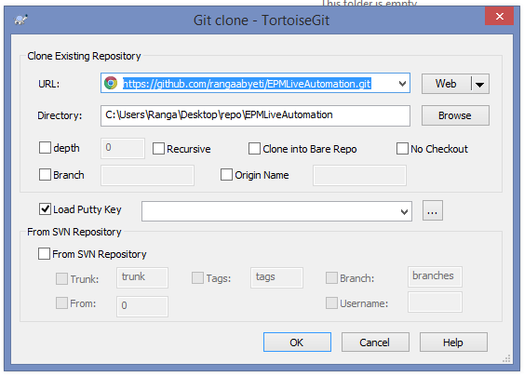

Set in URL: **https://github.com/rangaabyeti/EPMLiveAutomation.git**

Once you click OK, a repository copy is created in your machine

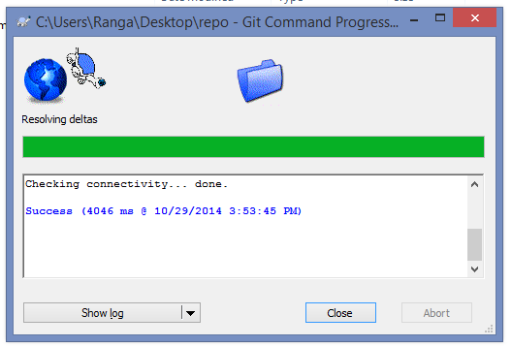

When the processes is finished you should be a success message, and then click **Close**

When the download finished, right click in the **Automation** folder and go to **TortoiseGit► Switch/Checkout…**

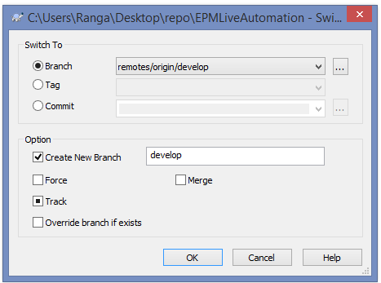

Once you click on 'OK' button, a repository will switch to develop branch

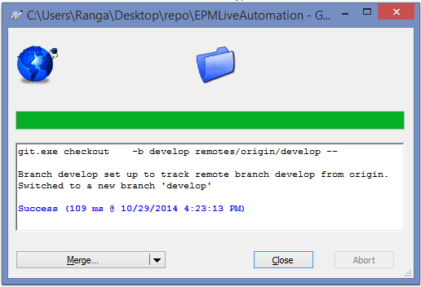

When the processes is finished you should be a success message, and then click **Close**

# Pull and push of code :

Before modify any file first pull repository

Pull:

go to **TortoiseGit► pull...**

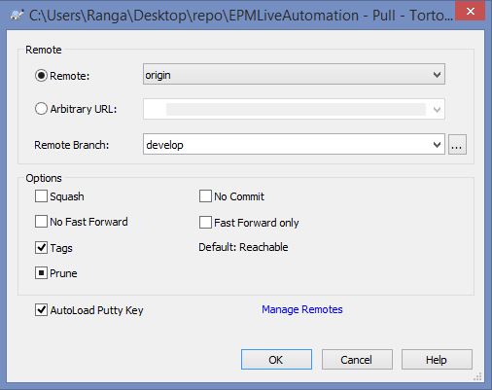

Once you click on 'OK' button, it will get you latest repository code

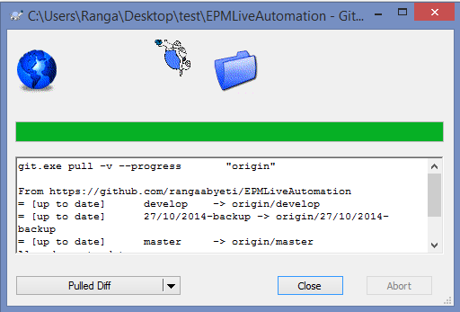

When the processes is finished you should be a success message, and then click **Close**